**UNIVERSITY PERFOMANCE MODEL**

* Tejasvi Bhadrinath (002952291)
* Rahul Udhayakumar(002989204)
* Abhinav Manoj Menon (001525815)

**INTRODUCTION**

Education is a very powerful tool to change the world. Education is provided by various universities. In this project we are trying to use the various software techniques to measure the quality of education for a particular university. The same model can be implemented to various universities as well. In here we are receiving feedback on Students from Employers they work for and also from students on which professors and courses impacted their careers to make them successful in their careers.

**ENTITIES**

* **University:** This entity holds administrator privileges to monitor entire university.
* **Department:** This contains the various departments in the university and along with the students and faculty that is contained in the department.
* **Course CatLog:** It contains list of the all the courses along with other course information.
* **Faculty Directory:** This contains complete faculty information about faculties at the university.
* **Faculty Profile:** The basic information about the faculty is available in the entity.
* **Calendar:** It contains the course schedule for each course in the university.
* **Department Account:** Holds information of financial importance for each department.
* **Course Management:** Contains all data about various courses assigned to each student.
* **Faculty Assignment:** It provides information on faculty assigned to each course and feedback of students on their professors.
* **Alumni:** This entity contains all information about graduated students and about their career trajectory so far.
* **Seat:** The number of seats for a course in a semester, how many seats are taken and how many are left.
* **Course:** Contains information on course name, the number of credits it is and the total price of the course.
* **Alumni Profile:** The basic information of Alumni is stored in this entity such as graduated year current salary and designation.
* **Degree:** Contains list of courses a student has completed, if he has completed the requirements for the degree, their selected electives.
* **Transcript:** All information of the student along with the list of courses taken and their performance so far academically.
* **Student Directory:** To create a new student profile also contains profile of all students in the university.
* **Person Directory:** Contains all people associated the university notwithstanding their position in the university.
* **Employment History:** This contains the alumni information on courses of impact and ratings for each course and along with alumni employer information.
* **Employment:** Holds employment information of alumni, salary, job title.
* **Employer Directory:** Holds various employers of alumni and employer information.
* **Employer Profile:** This contains number of employments by an employer and each employer name.
* **Feedback Management:** This manages various feedback from employer on alumni and alumni, student feedback on various courses and professors.

**UML DIAGRAM**

**OBJECT MODEL DIAGRAM:**

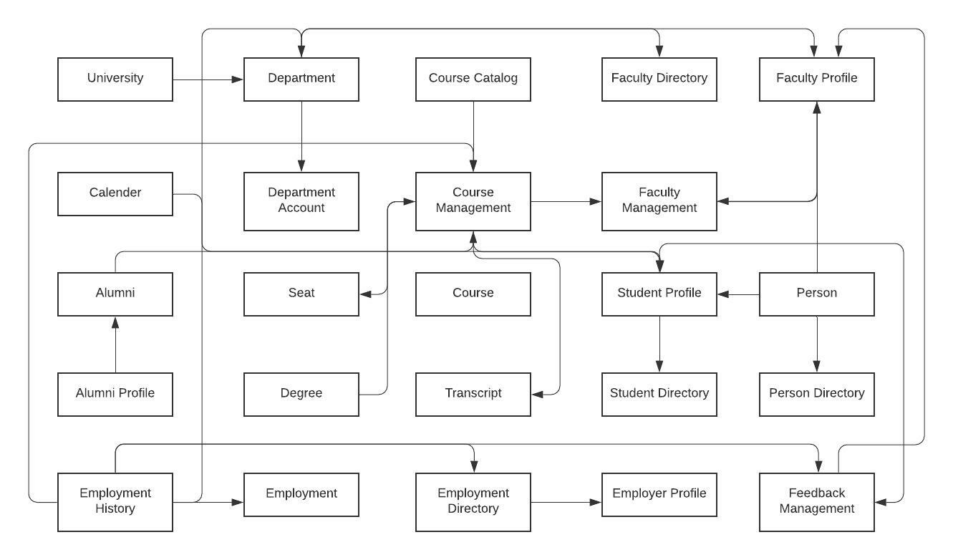

**SEQUENCE DIAGRAM: Transcript Flow**

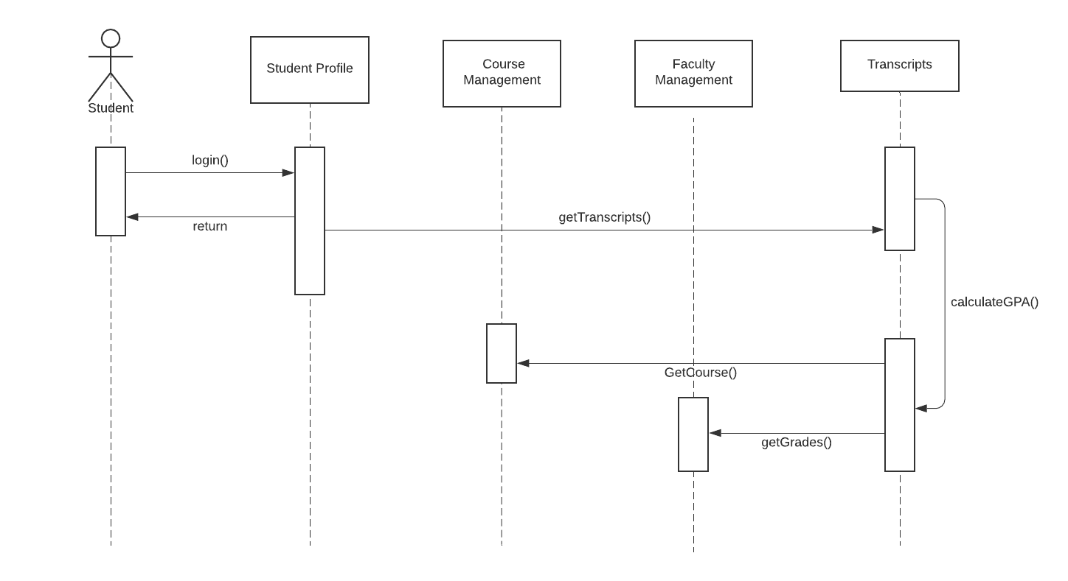

**SEQUENCE DIAGRAM: Feedback Flow**

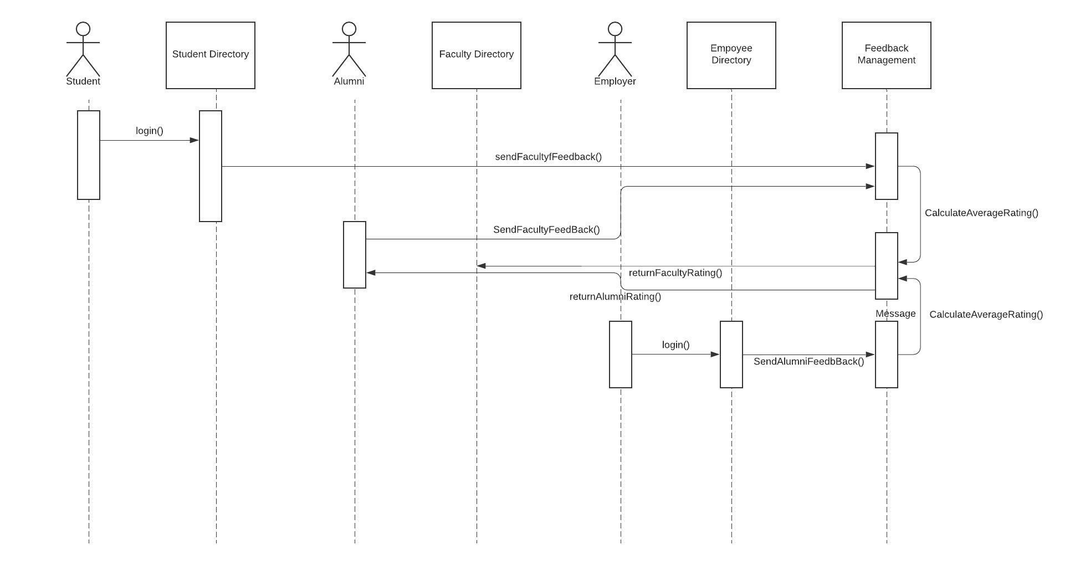

**DASHBOARDS:**

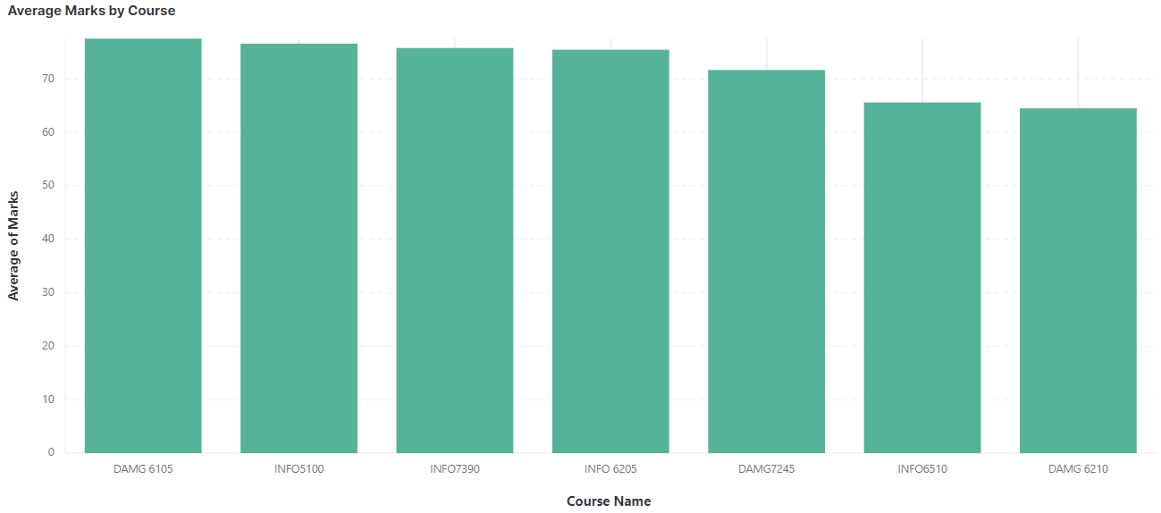

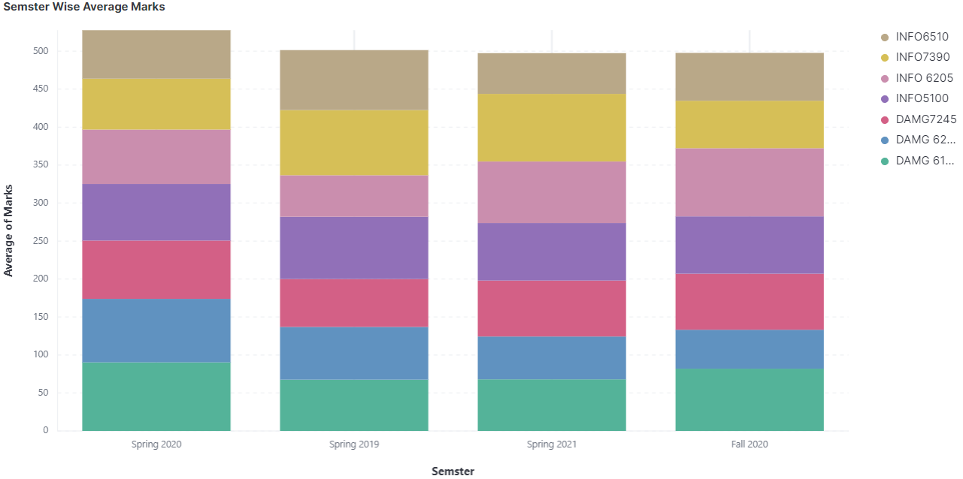

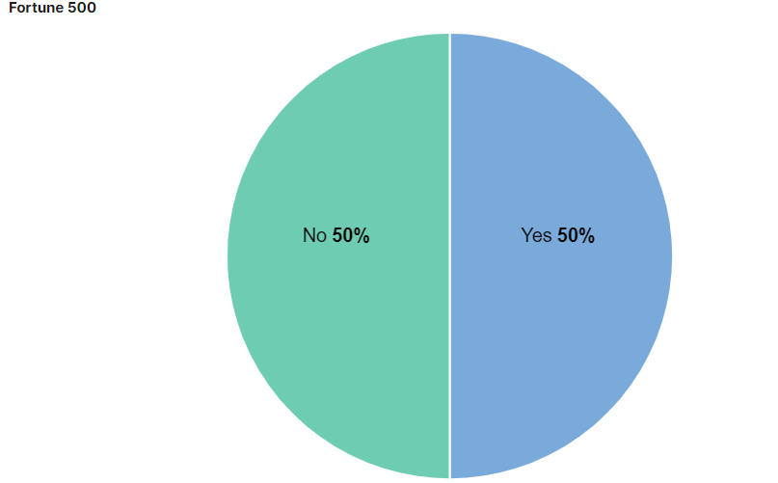

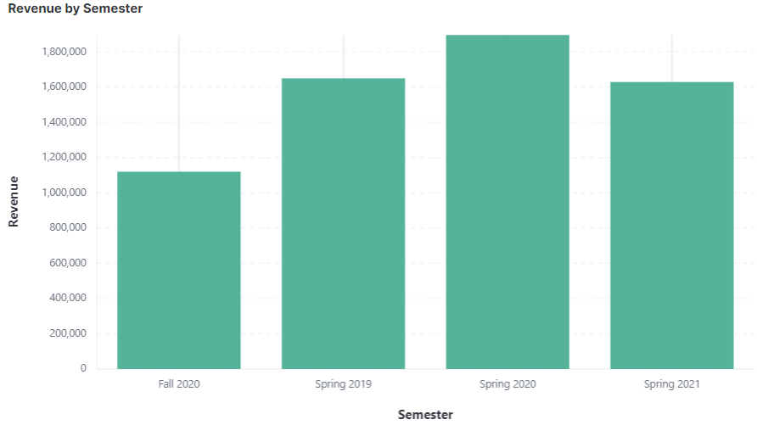

**USER INTERFACE:**

Login Page:

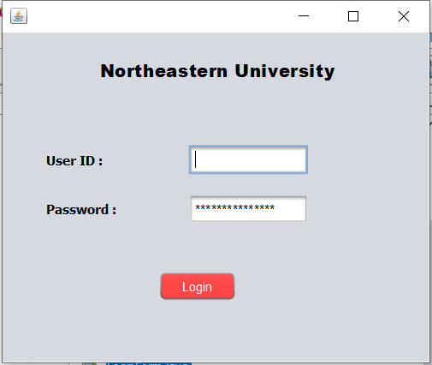

Main Page:

Student Page:

Alumni Page:

Employer Page:

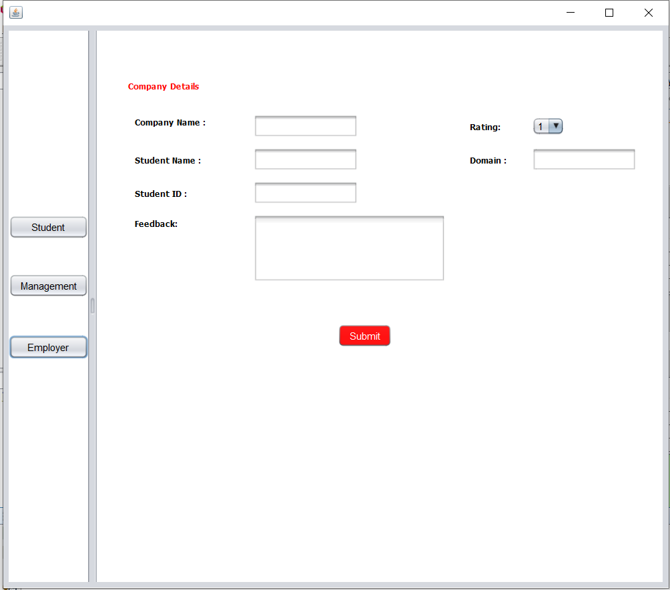

Management Page:

